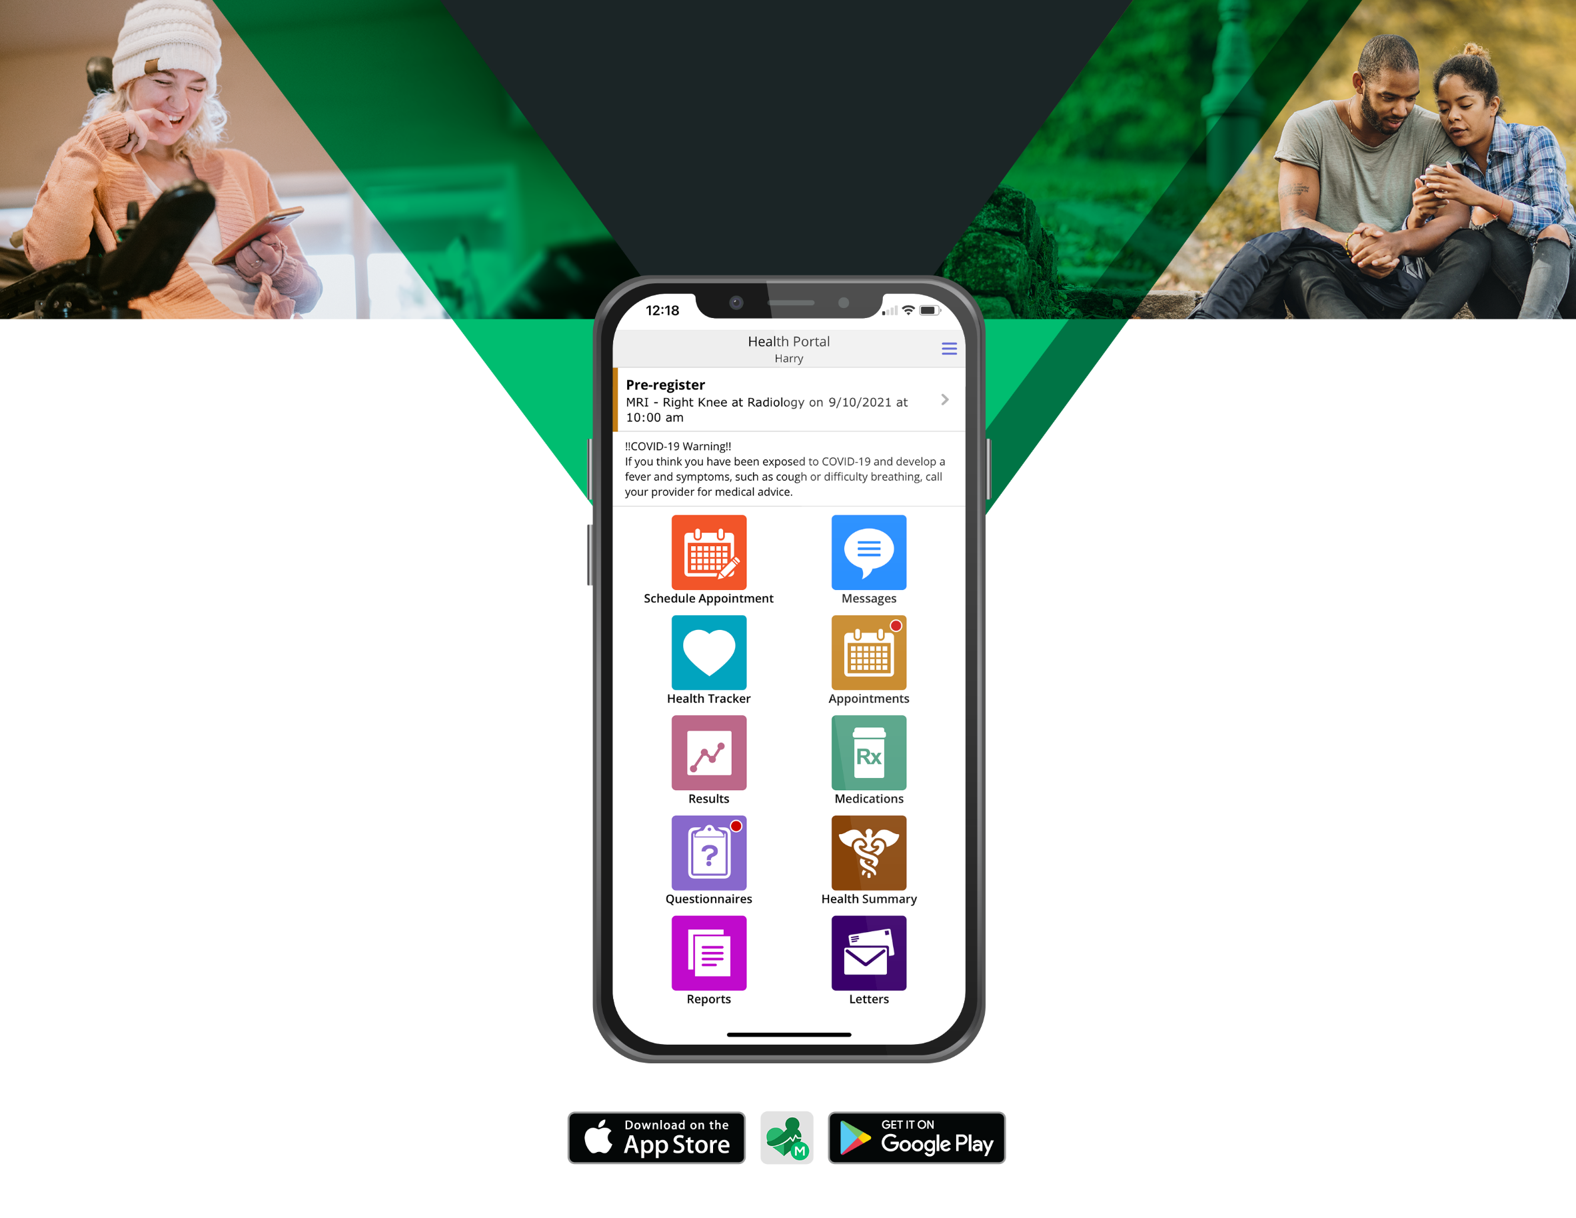

Beyond a variety of health management features, [the Portal] provides:

Additional Benefits

**SHARED ACCESS**

You can grant access to your [Portal] to trusted individuals, such as family members, and can specify which types of information they can see.

**SECURITY**

[The Portal] is encrypted, rewrites URLs, and times out after inactivity, making it safe to use on personal or public devices.

**INTEGRATION**

All of the information in [the Portal] comes from your [Healthcare Organization] Electronic Health Record to ensure you have accurate, up-to-date information.

**SUPPORT**

Each Portal page includes Contact Us and Learn More sections to get help with your technical questions.

Essential

Information and Tools

Use [the Portal] on mobile devices

by downloading the MHealth app

from the Apple App Store or

Google Play Store.

[The Portal] lets you manage your health information and care easily and securely. It includes:

**HEALTH INFORMATION**

* Lab and exam results
* Allergies and conditions
* Immunizations
* Medications, including renewals
* Visit history
* Discharge instructions
* Health summary.

**APPOINTMENTS**

* Appointment requests
* Visit information, such as instructions and directions.

**COMMUNICATION**

* Provider messaging
* Virtual visits
* Check-in, including the ability to fill out forms.

**BILLING**

* Online bill pay
* Outstanding balances.

Smartphone Friendly

**HEALTH INFORMATION**

Lab Results

Radiology Reports

Visit History

Discharge Instructions

Health Summary

**ALLERGIES AND**

**MEDICATIONS**

Allergies and Conditions

Immunizations

Medications with Instructions

**APPOINTMENTS**

Appointment Requests

Upcoming Visits

**BILLING**

Online Bill Pay

Outstanding Balances

The [Patient and Consumer Health Portal] is an online tool that goes a step beyond simply displaying information by helping you manage your healthcare easily and securely.

FAQs: You Have Questions,

We Have Answers

All of Your Information,

in One Place

How the Portal

Works for You

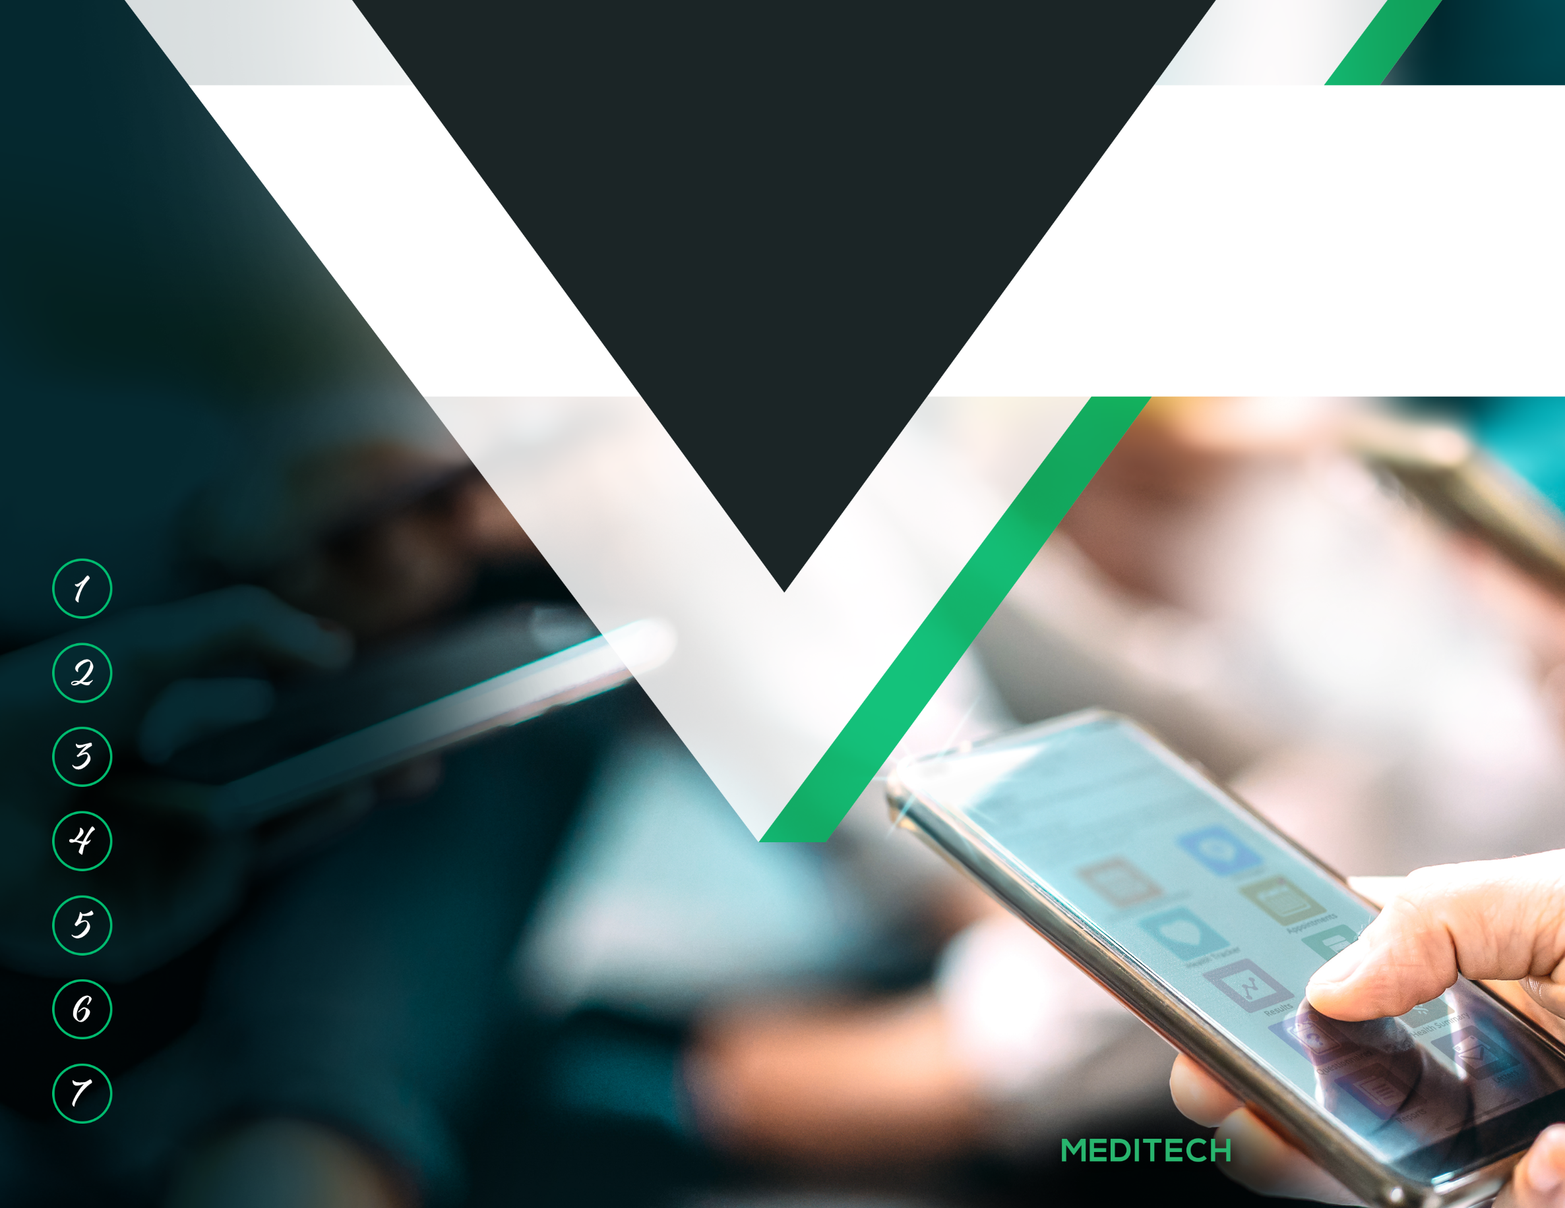

[Organization Name]

Simple

Enrollment

**Visit** the Apple or Google Play stores and download the MHealth app

**Complete** enrollment questionnaire by providing name, DOB, email, etc.

**Click** on [the Portal] link

**Explore** [the Portal]!

**Select** a new username

and password

**Access** your email and click [the Portal] link

**Visit** our website [www.organization.org]

**Had a recent visit?** If so, check

your email for your [Portal] invitation! Otherwise, to begin using the Portal:

[Organization

Logo/Name]

**Contact Us:**

[Phone number]

[Email address]

[Organization address]

**MANAGE**

Your Health

Information

**COMMUNICATE**

with Your Providers

**TAKE**

an Active Role

in Your Care

[Patient and

Consumer Health

Portal]

Visit the Apple or Google Play stores and download the MHealth app

**Explore the Portal!**

Select a new user name and password

Access your email and click on a link to the Portal

Complete enrollment questionnaire (name, DOB, email, etc.)

Click on the [Patient and Consumer Health Portal] link

Visit our website:

[www.organization.org]

**Enrollment is Easy**

**Smartphone Friendly**

Access *your* health information from *your* phone

**[Organization Name]**

**Contact Us:**

[Phone Number]

[Email Address]

[Street Address]

[City, State, Zip Code]

[www.organization.org]

**[Organization Name]**

[Patient and Consumer Health Portal]

**STAY**

in Good Health

**STAY**

in Touch

**STAY**

Informed